

Best Practices

Concierge Assistant

The Master Computer

The Master Computer is a conveniently placed computer that you select to use when your network is unavailable. If you select to define a Master Computer the Concierge Assistant will take a "snapshot" of your database every ten (10) minutes. This snapshot of your database is copied to your Master Computer. When your network is not available you still have the opportunity to look-up any information in the system as of the last snapshot. If you have a local printer installed you may print as well. You will not be able to add or change information in the snapshot database but you can respond to your Guests inquiries and requests.

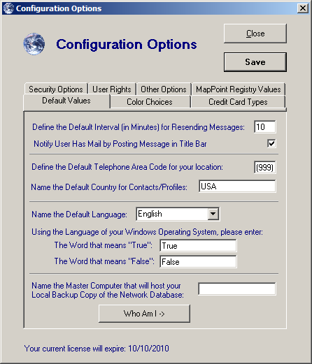
To use the Master Computer feature of The Concierge Assistant you must do the setup on the computer selected. Click on the Administration tab and select Configuration Options. At the bottom of the first screen you will see the text box asking for the name of the Master Computer you wish to use. Press the button “Who Am I”

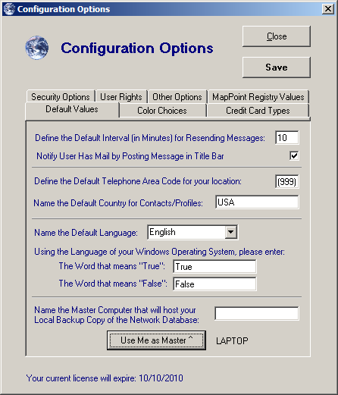
The Concierge Assistant will identify the name of the computer selected.

The button has changed from “Who Am I” to “Use Me as Master”. Press this button to designate this is the computer to be used as the Master computer.

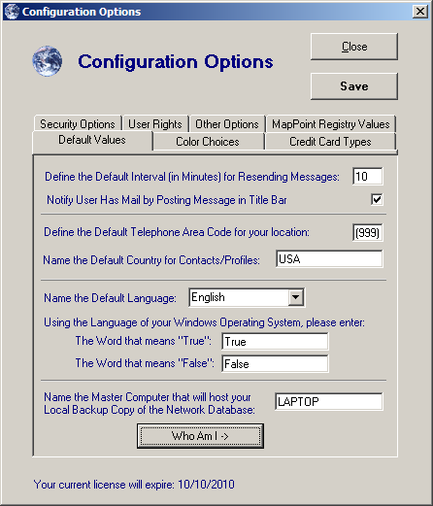
The name of the computer will be entered by the system into the appropriate slot.

Be sure to click on the “Save” button.

Simply follow this same procedure if you find it necessary to select a different workstation as the new “Master Computer”

